**ACKNOWLEDGEMENT**

We would like to express our deepest appreciation to all those who provided us the possibility to complete this project. Primarily we wish to express our unfathomable gratitude to our respected Principal Dr.J.Janet, Sri Krishna College of Engineering and Technology for providing the opportunity and necessary facilities in carrying out the project.

We express our sincere thanks and deep sense of gratitude to our Head of the Department Dr.S.Shankar, Department of Information Technology for his encouragement and support that he extended towards dissertation work. His help was meaningful and made us a better public presenter and a more communicative person in working environments while boosting our confidence and our analytical skills.

A special gratitude we give to our academic advisor, Dr.T.Sujatha whose contribution in stimulating suggestions and encouragement helped us to coordinate our project especially in designing and preparing this documentation. Her ideas, experience and advice led me to extract the optimal results of the project and helped us to become a better engineer in general.

A special thanks goes to our **project guide** who-with patience-helped us to understand and follow parts of the project that were completely new to us and provided to us knowledge that we were lacking.

We also wish to thank the Teaching and Non-Teaching faculties Department of Information Technology, Sri Krishna college of Engineering and Technology for providing their support to complete this project.

**ABSTRACT**

Today energy resources are becoming scarcer and therefore more valuable. In conjunction with the population growth over last century, the need for finding new, more efficient, and sustainable methods of agricultural cultivation and food production has become more critical. To facilitate this process, we are designing, building, and evaluating a system for precision agriculture which provides farmers with useful data about the soil, the water supply, and the general condition of their fields in a user friendly, easily accessible manner. Our system aims to make cultivation and irrigation more efficient as the farmer is able to make better informed decisions and thus save time and resources. The diversity of location and climatic effects upon agricultural cultivation, along with other environmental parameters over time makes the farmer’s decision-making process more complicated and requires additional empirical knowledge.

Applying wireless sensor networks for monitoring environmental parameters and combining this information with a user-customized web service may enable farmers to exploit their knowledge in an efficient way in order to extract the best results from their agricultural cultivation. The system can scale based on each farmer’s demands and the resulting ensemble of collected information may represent a valuable resource for future use, in addition to its use for real-time decision making. The design of the precision agriculture system contains a prototype solution regarding the sensor platform and a customizable service that can be utilized in different ways and by several entities.

**CHAPTER 1**

**INTERNET OF THINGS**

**1.1 Introduction**

The **Internet of things** (**Iota**) is the inter-networking of physical devices, vehicles (also referred to as "connected devices" and "smart devices"), buildings, and other items—embedded with electronics, software, sensors, actuators, and network connectivity that enable these objects to collect and exchange data. In 2013 the Global Standards Initiative on Internet of Things (IoT-GSI) defined the IoT as "the infrastructure of the information society." The IoT allows objects to be sensed or controlled remotely across existing network infrastructure, creating opportunities for more direct integration of the physical world into computer-based systems, and resulting in improved efficiency, accuracy and economic benefit in addition to reduced human intervention. When IoT is augmented with sensors and actuators, the technology becomes an instance of the more general class of cyber-physical systems, which also encompasses technologies such as smart grids, virtual power plants, smart homes, intelligent transportation and smart cities. Each thing is uniquely identifiable through its embedded computing system but is able to interoperate within the existing Internet infrastructure. Experts estimate that the IoT will consist of almost 50 billion objects by 2020.

Typically, IoT is expected to offer advanced connectivity of devices, systems, and services that goes beyond machine-to-machine (M2M) communications and covers a variety of protocols, domains, and applications. The interconnection of these embedded devices (including smart objects), is expected to usher in automation in nearly all fields, while also enabling advanced applications like a smart grid, and expanding to areas such as smart cities.

"Things," in the IoT sense, can refer to a wide variety of devices such as heart monitoring implants, biochip transponders on farm animals, electric clams in coastal waters, automobiles with built-in sensors, DNA analysis devices for environmental/food/pathogen monitoring or field operation devices that assist fire-fighters in search and rescue operations. Legal scholars suggest looking at "Things" as an "inextricable mixture of hardware, software, data and service". These devices collect useful data with the help of various existing technologies and then autonomously flow the data between other devices. Current market examples include home automation (also known as smart home devices) such as the control and automation of lighting, heating (like smart thermostat), ventilation, air conditioning (HVAC) systems, and appliances such as washer/dryers, robotic vacuums, air purifiers, ovens or refrigerators/freezers that use Wi-Fi for remote monitoring.

As well as the expansion of Internet-connected automation into a plethora of new application areas, IoT is also expected to generate large amounts of data from diverse locations, with the consequent necessity for quick aggregation of the data, and an increase in the need to index, store, and process such data more effectively. IoT is one of the platforms of today's Smart City, and Smart Energy Management Systems. The term "the Internet of Things" was coined by Kevin Ashton of Procter & Gamble, later MIT's Auto-ID Centre, in 1999.

## 1.2 Application

The ability to network embedded devices with limited CPU, memory and power resources means that IoT finds applications in nearly every field. Such systems could be in charge of collecting information in settings ranging from natural ecosystems to buildings and factories, thereby finding applications in fields of environmental sensing and urban planning.

On the other hand, IoT systems could also be responsible for performing actions, not just sensing things. Intelligent shopping systems, for example, could monitor specific users' purchasing habits in a store by tracking their specific mobile phones. These users could then be provided with special offers on their favourite products, or even location of items that they need, which their fridge has automatically conveyed to the phone. Additional examples of sensing and actuating are reflected in applications that deal with heat, water, electricity and energy management, as well as cruise-assisting transportation systems. Other applications that the Internet of things can provide is enabling extended home security features and home automation. The concept of an "Internet of living things" has been proposed to describe networks of biological sensors that could use cloud-based analyses to allow users to study DNA or other molecules.

However, the application of the IoT is not only restricted to these areas. Other specialized use cases of the IoT may also exist. An overview of some of the most prominent application areas is provided here. Based on the application domain, IoT products can be classified broadly into five different categories: smart wearable, smart home, smart city, smart environment, and smart enterprise. The IoT products and solutions in each of these markets have different characteristics.

**1.2.1 Media**

In order to hone the manner in which things, media and big data are interconnected, it is first necessary to provide some context into the mechanism used for media process. It has been suggested by Nick Couldry and Joseph Turow that [practitioners](https://en.wiktionary.org/wiki/practitioner) in media approach big data as many actionable points of information about millions of individuals. The industry appears to be moving away from the traditional approach of using specific media environments such as newspapers, magazines, or television shows and instead tap into consumers with technologies that reach targeted people at optimal times in optimal locations. The ultimate aim is of course to serve, or convey, a message or content that is in line with the consumer's mindset. For example, publishing environments are increasingly tailoring the messages (advertisements) and content (articles) to appeal to consumers that have been exclusively gleaned through various data-mining activities. The media industries process big data in a dual, interconnected manner:

* Targeting of consumers (for advertising by marketers)
* Data-capture

Thus, the Internet of things creates an opportunity to measure, collect and analyse an ever-increasing variety of behavioural statistics. Cross-correlation of this data could revolutionise the targeted marketing of products and services. For example, as noted by Danny Meadows-Klue, the combination of [analytics](https://en.wikipedia.org/wiki/Analytics) for [conversion tracking](https://en.wikipedia.org/wiki/Conversion_tracking) with [behavioural targeting](https://en.wikipedia.org/wiki/Behavioural_targeting) has unlocked a new level of precision that enables display advertising to be focused on the devices of people with relevant interests. Big data and the IoT work in conjunction. From a media perspective, data is the key derivative of device interconnectivity, whilst being pivotal in allowing clearer accuracy in targeting. The Internet of things therefore transforms the media industry, companies and even governments, opening up a new era of economic growth and competitiveness. The wealth of data generated by this industry (i.e. big data) will allow practitioners in advertising and media to gain an elaborate layer on the present targeting mechanisms used by the industry.

### 1.2.2Environmental monitoring

Environmental monitoring applications of the IoT typically use sensors to assist in environmental protection by monitoring air or water quality atmospheric or soil conditions, and can even include areas like monitoring the movements of wildlife and their habitats. Development of resource constrained devices connected to the Internet also means that other applications like earthquake or tsunami early-warning systems can also be used by emergency services to provide more effective aid. IoT devices in this application typically span a large geographic area and can also be mobile. It has been argued that the standardization IoT brings to wireless sensing will revolutionize this area.

### 1.2.3 Infrastructure management

Monitoring and controlling operations of urban and rural infrastructures like bridges, railway tracks, on- and offshore- wind-farms is a key application of the IoT. The IoT infrastructure can be used for monitoring any events or changes in structural conditions that can compromise safety and increase risk. It can also be used for scheduling repair and maintenance activities in an efficient manner, by coordinating tasks between different service providers and users of these facilities. IoT devices can also be used to control critical infrastructure like bridges to provide access to ships. Usage of IoT devices for monitoring and operating infrastructure is likely to improve incident management and emergency response coordination, and quality of service, up-times and reduce costs of operation in all infrastructure related areas. Even areas such as waste management can benefit from automation and optimization that could be brought in by the IoT.

### 1.2.4 Manufacturing

Network control and management of manufacturing equipment, asset and situation management, or manufacturing process control bring the IoT within the realm of industrial applications and smart manufacturing as well. The IoT intelligent systems enable rapid manufacturing of new products, dynamic response to product demands, and real-time optimization of manufacturing production and supply chain networks, by networking machinery, sensors and control systems together.

Digital control systems to automate process controls, operator tools and service information systems to optimize plant safety and security are within the purview of the IoT. But it also extends itself to asset management via predictive maintenance, statistical evaluation, and measurements to maximize reliability. Smart industrial management systems can also be integrated with the Smart Grid, thereby enabling real-time energy optimization. Measurements, automated controls, plant optimization, health and safety management, and other functions are provided by a large number of networked sensors.

National Science Foundation established an Industry/University Cooperative Research Centre on intelligent maintenance systems (IMS) in 2001 with a research focus to use IoT-based predictive analytics technologies to monitor connected machines and to predict machine degradation, and further to prevent potential failures. The vision to achieve near-zero breakdown using IoT-based predictive analytics led the future development of e-manufacturing and e-maintenance activities.

The term IIoT (Industrial Internet of Things) is often encountered in the manufacturing industries, referring to the industrial subset of the IoT. IIoT in manufacturing would probably generate so much business value that it will eventually lead to the fourth industrial revolution, so the so-called Industry 4.0. It is estimated that in the future, successful companies will be able to increase their revenue through Internet of things by creating new business models and improve productivity, exploit analytics for innovation, and transform workforce. The potential of growth by implementing IIoT will generate $12 trillion of global GDP by 2030.

[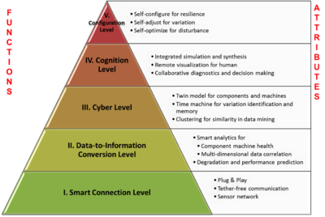](https://en.wikipedia.org/wiki/File:CPS_for_Manufacturing.png)

Figure 1: Design architecture of cyber-physical systems-enabled manufacturing system

While connectivity and data acquisition are imperative for IIoT, they should not be the purpose, rather the foundation and path to something bigger. Among all the technologies, predictive maintenance is probably a relatively "easier win" since it is applicable to existing assets and management systems. The objective of intelligent maintenance systems is to reduce unexpected downtime and increase productivity. And to realize that alone would generate around up to 30% over total maintenance costs. Industrial big data analytics will play a vital role in manufacturing asset predictive maintenance, although that is not the only capability of industrial big data. Cyber-physical systems (CPS) is the core technology of industrial big data and it will be an interface between human and the cyber world. Cyber-physical systems can be designed by following the *5C* (connection, conversion, cyber, cognition, configuration) architecture and it will transform the collected data into actionable information, and eventually interfere with the physical assets to optimize processes.

An IoT-enabled intelligent system of such cases has been demonstrated by the NSF Industry/University Collaborative Research Centre for Intelligent Maintenance Systems (IMS) at University of Cincinnati on a band saw machine in IMTS 2014 in Chicago. Band saw machines are not necessarily expensive, but the band saw belt expenses are enormous since they degrade much faster. However, without sensing and intelligent analytics, it can be only determined by experience when the band saw belt will actually break. The developed prognostics system will be able to recognize and monitor the degradation of band saw belts even if the condition is changing, so that users will know in near real time when is the best time to replace band saw. This will significantly improve user experience and operator safety, and save costs on replacing band saw belts before they actually break. The developed analytical algorithms were realized on a cloud server, and was made accessible via the Internet and on mobile devices.

### 1.2.5 Energy management

Integration of sensing and actuation systems, connected to the Internet, is likely to optimize energy consumption as a whole. It is expected that IoT devices will be integrated into all forms of energy consuming devices (switches, power outlets, bulbs, televisions, etc.) and be able to communicate with the utility supply company in order to effectively balance power generation and energy usage. Such devices would also offer the opportunity for users to remotely control their devices, or centrally manage them via a cloud based interface, and enable advanced functions like scheduling (e.g., remotely powering on or off heating systems, controlling ovens, changing lighting conditions etc.).

Besides home based energy management, the IoT is especially relevant to the Smart Grid since it provides systems to gather and act on energy and power-related information in an automated fashion with the goal to improve the efficiency, reliability, economics, and sustainability of the production and distribution of electricity. Using advanced metering infrastructure (AMI) devices connected to the Internet backbone, electric utilities can not only collect data from end-user connections, but also manage other distribution automation devices like transformers and recloses.

### 1.2.6 Medical and healthcare

IoT devices can be used to enable remote health monitoring and emergency notification systems. These health monitoring devices can range from blood pressure and heart rate monitors to advanced devices capable of monitoring specialized implants, such as pacemakers Fit bit electronic wristbands or advanced hearing aids. Some hospitals have begun implementing "smart beds" that can detect when they are occupied and when a patient is attempting to get up. It can also adjust itself to ensure appropriate pressure and support is applied to the patient without the manual interaction of nurses. Specialized sensors can also be equipped within living spaces to monitor the health and general well-being of senior citizens, while also ensuring that proper treatment is being administered and assisting people regain lost mobility via therapy as well Other consumer devices to encourage healthy living, such as, connected scales or wearable heart monitors, are also a possibility with the IoT. More and more end-to-end health monitoring IoT platforms are coming up for antenatal and chronic patients, helping one manage health vitals and recurring medication requirements.

### 1.2.7 Building and home automation

IoT devices can be used to monitor and control the mechanical, electrical and electronic systems used in various types of buildings (e.g., public and private, industrial, institutions, or residential)in home automation and building automation systems.

### 1.2.8 Transportation

The IoT can assist in integration of communications, control, and information processing across various transportation systems. Application of the IoT extends to all aspects of transportation systems (i.e. the vehicle, the infrastructure, and the driver or user). Dynamic interaction between these components of a transport system enables inter and intra vehicular communication, smart traffic control, smart parking, electronic toll collection systems, logistic and fleet management, vehicle control, and safety and road assistance.

### 1.2.9 Metropolitan scale deployments

There are several planned or ongoing large-scale deployments of the IoT, to enable better management of cities and systems. For example, Songdo, South Korea, the first of its kind fully equipped and wired smart city, is near completion. Nearly everything in this city is planned to be wired, connected and turned into a constant stream of data that would be monitored and analyzed by an array of computers with little, or no human intervention.

Another application is a currently undergoing project in Santander, Spain. For this deployment, two approaches have been adopted. This city of 180,000 inhabitants, has already seen 18,000 city application downloads for their smartphones. This application is connected to 10,000 sensors that enable services like parking search, environmental monitoring, digital city agenda among others. City context information is used in this deployment so as to benefit merchants through a spark deals mechanism based on city behaviour that aims at maximizing the impact of each notification.

Other examples of large-scale deployments underway include the Sino-Singapore Guangzhou Knowledge City; work on improving air and water quality, reducing noise pollution, and increasing transportation efficiency in San Jose, California; and smart traffic management in western Singapore. French company, Sigfox, commenced building an ultra-narrowband wireless data network in the San Francisco Bay Area in 2014, the first business to achieve such a deployment in the U.S.It subsequently announced it would set up a total of 4000 base stations to cover a total of 30 cities in the U.S. by the end of 2016, making it the largest IoT network coverage provider in the country thus far.

Another example of a large deployment is the one completed by New York Waterways in New York City to connect all the city's vessels and be able to monitor them live 24/7. The network was designed and engineered by Fluidmesh Networks, a Chicago-based company developing wireless networks for critical applications. The NYWW network is currently providing coverage on the Hudson River, East River, and Upper New York Bay. With the wireless network in place, NY Waterway is able to take control of its fleet and passengers in a way that was not previously possible. New applications can include security, energy and fleet management, digital signage, public Wi-Fi, paperless ticketing and others.

### 1.2.10 Consumer application

A growing portion of IoT devices are created for consumer use. Examples of consumer applications include connected car, entertainment, residences and smart homes, wearable technology, quantified self, connected health, and smart retail. Consumer IoT provides new opportunities for user experience and interfaces.

Some consumer applications have been criticized for their lack of redundancy and their inconsistency, leading to a popular parody known as the “Internet of Shit.” Companies have been criticized for their rush into IoT, creating devices of questionable value, and not setting up stringent security standards.

## 1.3 Trends and characteristics

### 1.3.1 Intelligence

Ambient intelligence and autonomous control are not part of the original concept of the Internet of things. Ambient intelligence and autonomous control do not necessarily require Internet structures, either. However, there is a shift in research to integrate the concepts of the Internet of things and autonomous control, with initial outcomes towards this direction considering objects as the driving force for autonomous IoT.

In the future the Internet of things may be a non-deterministic and open network in which auto-organized or intelligent entities (Web services, SOA components), virtual objects (avatars) will be interoperable and able to act independently (pursuing their own objectives or shared ones) depending on the context, circumstances or environments. Autonomous behaviour through the collection and reasoning of context information as well as the objects ability to detect changes in the environment, faults affecting sensors and introduce suitable mitigation measures constitute a major research trend, clearly needed to provide credibility to the IoT technology. Modern IoT products and solutions in the marketplace use a variety of different technologies to support such context-aware automation but more sophisticated forms of intelligence are requested to permit sensor units to be deployed in real environments.

### 1.3.2 Architecture

The system will likely be an example of event-driven architecture, bottom-up made (based on the context of processes and operations, in real-time) and will consider any subsidiary level. Therefore, model driven and functional approaches will coexist with new ones able to treat exceptions and unusual evolution of processes (multi-agent systems, B-ADSc, etc.).

In an Internet of things, the meaning of an event will not necessarily be based on a deterministic or syntactic model but would instead be based on the context of the event itself: this will also be a semantic web. Consequently, it will not necessarily need common standards that would not be able to address every context or use: some actors (services, components, avatars) will accordingly be self-referenced and, if ever needed, adaptive to existing common standards (*predicting everything* would be no more than defining a "global finality" for everything that is just not possible with any of the current *top-down* approaches and standardizations). Some researchers argue that sensor networks are the most essential components of the Internet of things.

Building on top of the Internet of things, the web of things is architecture for the application layer of the Internet of things looking at the convergence of data from IoT devices into Web applications to create innovative use-cases. In order to program and control the flow of information in the Internet of things, a predicted architectural direction is being called BPM Everywhere which is a blending of traditional process management with process mining and special capabilities to automate the control of large numbers of coordinated devices.

#### 1.3.3 Network architecture

The Internet of things requires huge scalability in the network space to handle the surge of devices. IETF 6LoWPAN would be used to connect devices to IP networks. With billions of devices being added to the Internet space, IPv6 will play a major role in handling the network layer scalability. IETF's Constrained Application Protocol, MQTT and ZeroMQ would provide lightweight data transport.

Fog computing is a viable alternative to prevent such large burst of data flow through Internet. The edge devices' computation power can be used to analyse and process data, thus providing easy real time scalability.

### 1.3.4 Complexity

In semi-open or closed loops (i.e. value chains, whenever a global finality can be settled) IoT will often be considered and studied as a complex system due to the huge number of different links, interactions between autonomous actors, and its capacity to integrate new actors. At the overall stage (full open loop) it will likely be seen as a chaotic environment (since systems always have finality). As a practical approach, not all elements in the Internet of things run in a global, public space. Subsystems are often implemented to mitigate the risks of privacy, control and reliability. For example, Domestic Robotics (Domotics) running inside a smart home might only share data within and be available via a local network.

### 1.3.5 Size considerations

The Internet of things would encode 50 to 100 trillion objects, and be able to follow the movement of those objects. Human beings in surveyed urban environments are each surrounded by 1000 to 5000 tractable objects.

### 1.3.6 Space considerations

In the Internet of things, the precise geographic location of a thing—and also the precise geographic dimensions of a thing—will be critical. Therefore, facts about a thing, such as its location in time and space, have been less critical to track because the person processing the information can decide whether or not that information was important to the action being taken, and if so, add the missing information (or decide to not take the action). (Note that some things in the Internet of things will be sensors, and sensor location is usually important.) The GeoWeb and Digital Earth are promising applications that become possible when things can become organized and connected by location. However, the challenges that remain include the constraints of variable spatial scales, the need to handle massive amounts of data, and an indexing for fast search and neighbour operations. In the Internet of things, if things are able to take actions on their own initiative, this human-centric mediation role is eliminated. Thus, the time-space context that we as humans take for granted must be given a central role in this information ecosystem. Just as standards play a key role in the Internet and the Web, geospatial standards will play a key role in the Internet of things.

### 1.3.7 Sectors

There are three core sectors of the IoT: enterprise, home, and government, with the Enterprise Internet of Things (EIoT) being the largest of the three. By 2019, the EIoT sector is estimated to account for nearly 40% or 9.1 billion devices.

## 1.4 Frameworks

IoT frameworks might help support the interaction between "things" and allow for more complex structures like distributed computing and the development of distributed applications. Currently, some IoT frameworks seem to focus on real-time data logging solutions like Jasper Technologies, Inc. and Xively (formerly Cosm and before that Pachube), offering some basis to work with many "things" and have them interact. Future developments might lead to specific software-development environments to create the software to work with the hardware used in the Internet of things. Companies are developing technology platforms to provide this type of functionality for the Internet of things. Newer platforms are being developed, which add more intelligence. Foremost, IBM has announced cognitive IoT, which combines traditional IoT with machine intelligence and learning, contextual information, industry-specific models, and even natural language processing. The XMPP Standards Foundation (XSF) is creating such a framework in a fully open standard that is neither tied to any company nor connected to any cloud services. This XMPP initiative is called Chatty Things.XMPP provides a set of needed building blocks and a proven distributed solution that can scale with high security levels.

## 1.5 Enabling technologies for IoT

There are many technologies that enable IoT. Crucial to the field is the network used to communicate between devices of an IoT installation, a role that several wireless or wired technologies may fulfil:

### 1.5.1 Short-range wireless

* Bluetooth low energy (BLE) – Specification providing a low power variant to classic Bluetooth with a comparable communication range.
* Light-Fidelity (Li-Fi) – Wireless communication technology similar to the Wi-Fi standard, but using visible light communication for increased bandwidth.
* Near-field communication (NFC) – Communication protocols enabling two electronic devices to communicate within a 4 cm range.
* QR codes and barcodes – Machine-readable optical tags that store information about the item to which they are attached.
* Radio-frequency identification (RFID) – Technology using electromagnetic fields to read data stored in tags embedded in other items.
* Thread – Network protocol based on the IEEE 802.15.4 standard, similar to ZigBee, providing IPv6 addressing.
* Transport Layer Security (network protocol)|TLS – Network security protocol.
* Wi-Fi – Widely used technology for local area networking based on the IEEE 802.11 standard, where devices may communicate through a shared access point.
* Wi-Fi Direct – Variant of the Wi-Fi standard for peer-to-peer communication, eliminating the need for an access point.
* Z-Wave – Communication protocol providing short-range, low-latency data transfer at rates and power consumption lower than Wi-Fi. Used primarily for home automation.
* ZigBee – Communication protocols for personal area networking based on the IEEE 802.15.4 standard, providing low power consumption, low data rate, low cost, and high throughput.

### 1.5.2 Medium-range wireless

* HaLow – Variant of the Wi-Fi standard providing extended range for low-power communication at a lower data rate.
* LTE-Advanced – High-speed communication specification for mobile networks. Provides enhancements to the LTE standard with extended coverage, higher throughput, and lower latency.

### 1.5.3 Long-range wireless

* Low-power wide-area networking (LPWAN) – Wireless networks designed to allow long-range communication at a low data rate, reducing power and cost for transmission.
* Very small aperture terminal (VSAT) – Satellite communication technology using small dish antennas for narrowband and broadband data.

### 1.5.4 Wired

* Ethernet – General purpose networking standard using twisted pair and fiber optic links in conjunction with hubs or switches.
* Multimedia over Coax Alliance (MoCA) – Specification enabling whole-home distribution of high definition video and content over existing coaxial cabling.
* Power-line communication (PLC) – Communication technology using electrical wiring to carry power and data. Specifications such as Home Plug utilize PLC for networking IoT devices.

## 1.6 Criticism and controversies

### 1.6.1 Platform fragmentation

IoT suffers from platform fragmentation and lack of technical standards a situation where the variety of IoT devices, in terms of both hardware variations and differences in the software running on them, makes the task of developing applications that work consistently between different inconsistent technology ecosystems hard. Customers may be hesitant to bet their IoT future on proprietary software or hardware devices that uses proprietary protocols that may fade or become difficult to customize and interconnect.

IoT's amorphous computing nature is also a problem for security, since patches to bugs found in the core operating system often do not reach users of older and lower-price devices. One set of researchers say that the failure of vendors to support older devices with patches and updates leaves more than 87% of active devices vulnerable.

### 1.6.2 Privacy, autonomy and control

Philip N. Howard, a professor and author, writes that the Internet of things offers immense potential for empowering citizens, making government transparent, and broadening information access. Howard cautions, however, that privacy threats are enormous, as is the potential for social control and political manipulation.

Concerns about privacy have led many to consider the possibility that big data infrastructures such as the Internet of things and Data Mining are inherently incompatible with privacy. Writer Adam Greenfield claims that these technologies are not only an invasion of public space but are also being used to perpetuate normative behaviour, citing an instance of billboards with hidden cameras that tracked the demographics of passersby who stopped to read the advertisement.

The Internet of Things Council compared the increased prevalence of digital surveillance due to the Internet of things to the conceptual panopticon described by Jeremy Bentham in the 18th Century. The assertion was defended by the works of French philosophers Michel Foucault and Gilles Deleuze. In Discipline and Punish: The Birth of the Prison Foucault asserts that the panopticon was a central element of the discipline society developed during the Industrial Era. Foucault also argued that the discipline systems established in factories and school reflected Bentham's vision of panopticism. In his 1992 paper "Postscripts on the Societies of Control," Deleuze wrote that the discipline society had transitioned into a control society, with the computer replacing the panopticon as an instrument of discipline and control while still maintaining the qualities similar to that of panopticism.

The privacy of households could be compromised by solely analyzing smart home network traffic patterns without dissecting the contents of encrypted application data, yet a synthetic packet injection scheme can be used to safely overcome such invasion of privacy.

Researchers have identified privacy challenges faced by all stakeholders in IoT domain, from the manufacturers and app developers to the consumers themselves, and examined the responsibility of each party in order to ensure user privacy at all times. Problems highlighted by the report include:

* User consent – somehow, the report says, users need to be able to give informed consent to data collection. Users, however, have limited time and technical knowledge.
* Freedom of choice – both privacy protections and underlying standards should promote freedom of choice.
* Anonymity – IoT platforms pay scant attention to user anonymity when transmitting data, the researchers note. Future platforms could, for example, use TOR or similar technologies so that users can't be too deeply profiled based on the behaviours of their "things".

In response to rising concerns about privacy and smart technology, in 2007 the British Government stated it would follow formal Privacy by Design principles when implementing their smart metering program. The program would lead to replacement of traditional power meters with smart power meters, which could track and manage energy usage more accurately. However the British Computer Society is doubtful these principles were ever actually implemented. In 2009 the Dutch Parliament rejected a similar smart metering program, basing their decision on privacy concerns. The Dutch program later revised and passed in 2011.

### 1.6.3 Data storage and analytics

A challenge for producers of IoT applications is to clean, process and interpret the vast amount of data which is gathered by the sensors. There is a solution proposed for the analytics of the information referred to as Wireless Sensor Networks. These networks share data among sensor nodes that are sending to a distributed system for the analytics of the sensory data.

Another challenge is the storage of this bulk data. Depending on the application there could be high data acquisition requirements which in turn lead to high storage requirements. Currently the internet is already responsible for 5% of the total energy generatedand this consumption will increase significantly when we start utilizing applications with multiple embedded sensors.

### 1.6.4 Security

Concerns have been raised that the Internet of things is being developed rapidly without appropriate consideration of the profound security challenges involvedand the regulatory changes that might be necessary. According to the Business Insider Intelligence Survey conducted in the last quarter of 2014, 39% of the respondents said that security is the biggest concern in adopting Internet of things technology. In particular, as the Internet of things spreads widely, cyber attacks are likely to become an increasingly physical (rather than simply virtual) threat. In a January 2014 article in Forbes, cyber security columnist Joseph Steinberg listed many Internet-connected appliances that can already "spy on people in their own homes" including televisions, kitchen appliances, cameras, and thermostats. Computer-controlled devices in automobiles such as brakes, engine, locks, hood and truck releases, horn, heat, and dashboard have been shown to be vulnerable to attackers who have access to the onboard network. In some cases, vehicle computer systems are Internet-connected, allowing them to be exploited remotely. By 2008 security researchers had shown the ability to remotely control pacemakers without authority. Later hackers demonstrated remote control of insulin pumps and implantable cardioverter defibrillators. David Pogue wrote that some recently published reports about hackers remotely controlling certain functions of automobiles were not as serious as one might otherwise guess because of various mitigating circumstances; such as the bug that allowed the hack having been fixed before the report was published, or that the hack required security researchers having physical access to the car prior to the hack to prepare for it.

The U.S. National Intelligence Council in an unclassified report maintains that it would be hard to deny "access to networks of sensors and remotely-controlled objects by enemies of the United States, criminals, and mischief makers... An open market for aggregated sensor data could serve the interests of commerce and security no less than it helps criminals and spies identify vulnerable targets. Thus, massively parallel sensor fusion may undermine social cohesion, if it proves to be fundamentally incompatible with Fourth-Amendment guarantees against unreasonable search." In general, the intelligence community views the Internet of things as a rich source of data.

As a response to increasing concerns over security, the Internet of Things Security Foundation (IoTSF) was launched on 23 September 2015. IoTSF has a mission to secure the Internet of things by promoting knowledge and best practice. Its founding board is made from technology providers and telecommunications companies including BT, Vodafone, Imagination Technologies and Pen Test Partners.

In 2016, a distributed denial of service attack powered by Internet of things devices running the Mirai malware took down a DNS provider and major web sites.

### 1.6.5 Design

Given widespread recognition of the evolving nature of the design and management of the Internet of things, sustainable and secure deployment of IoT solutions must design for "anarchic scalability."Application of the concept of anarchic scalability can be extended to physical systems (i.e. controlled real-world objects), by virtue of those systems being designed to account for uncertain management futures. This "hard anarchic scalability" thus provides a pathway forward to fully realize the potential of Internet of things solutions by selectively constraining physical systems to allow for all management regimes without risking physical failure.

Brown University computer scientist Michael Littman has argued that successful execution of the Internet of things requires consideration of the interface's usability as well as the technology itself. These interfaces need to be not only more user-friendly but also better integrated. If users need to learn different interfaces for their vacuums, their locks, their sprinklers, their lights, and their coffeemakers, it's tough to say that their lives have been made any easier.

**Chapter 3**

**PROPOSED AND EXISTING SYSTEM**

**3.1 Problem Statement:**

This is the project from the motivation of the farmers working in the farm lands are solely dependent on the rains and bore wells for irrigation of their land. In recent times, the farmers have been using irrigation technique through the manual control in which the farmers irrigate the land at regular intervals by turning the water-pump ON/OFF when required. Moreover, for the power indication they are glowing a single bulb between any one of phase and neutral, meanwhile when there is any phase deduction occurs in other phases, the farmer cannot know their supply is low. If they Switch ON any of the motor, there will be the sudden defuse in motor circuit. They may have to travel so far for SWITCHING ON/OFF the motor. They may be suffering from hot Sun, rain and night time too. After reaching their farm, they found that there is no power, so they quietly disappointed to it.

**3.3 Literature Survey:**

The concept of the Internet of Things first became popular in 1999, through the Auto-ID Centre at MIT and related market-analysis publications. Researchers have proposed different models for agriculture sector with one or multiple technologies mentioned above e.g. irrigation system based on soil water measurement to decide irrigation amount of the water is described in . Which uses the Bluetooth model for the communication which has its own limitations like limited range and device accommodation. In the year of 2009, an author suggested scheduling in the power supply to the sensors which will help in improve energy efficiency .

Use of IoT in agriculture is mentioned by an author in paper . However it shows lack of interoperability which is necessary when we talk about large agricultural fields. For comparison of energy consumption between two appliances, has used concepts of pervasive computing, data aggregation etc to monitor the environmental factors using Zigbee . Increase in number of sensors is suggested by the author to improve the accuracy of the data collected. However it might raise the issue of more power consumption as more nodes has been deployed. Approach to provide the real time information to the farmers about the land and crops is defined in the paper , which provides the necessary information yet it's a standalone system.

In the year of 2015 concepts of IoT, cloud-computing, Mobile computing are used in smart agriculture, which is network of smart wireless sensor nodes who shares the information with each other as well as central system.. Although researchers have proposed few models in agriculture domain using one or more of the technologies mentioned, we aim to develop an integrated system of multiple functionalities with data interpretation and simpler interface.

**3.4 Proposed System:**

Therefore, considering the current need of agriculture and previous drawbacks we propose a system which integrates the control of all the deployed systems in a single system. Which will make it easy to handle and better understanding of the results by naive users. As well as it will keep the farmer updated by the notifications for almost every related event that occurs in the field.

**3.4.1 System Overview**

The proposal consist of four sections; node1, node2, node3 and PC or mobile app to control system. In the present system, every node is integration with different sensors and devices and they are interconnected to one central server via wireless communication modules. The server sends and receives information from user end using internet connectivity. There are two modes of operation of the system; auto mode and manual mode. In auto mode system takes its own decisions and controls the installed devices whereas in manual mode user can control the operations of system using android app or PC commands.

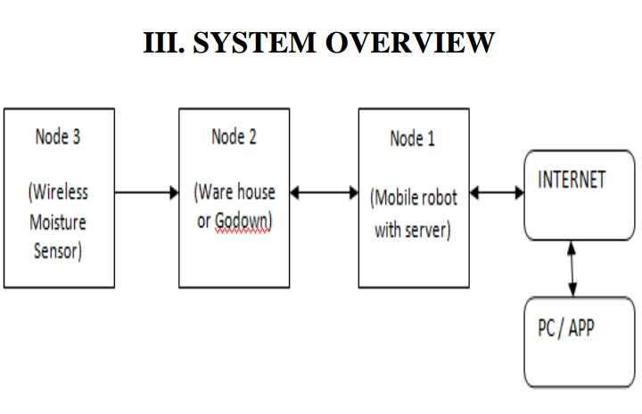

f

**3.4.2 System Architecture**

Node 1: Node1 is GPS based mobile robot which can be controlled remotely using computer as well as it can be programmed so as to navigate autonomously within the boundary of field using the co-ordinates given by GPS module. The Remote controlled robot have various sensors and devices like camera, obstacle sensor, siren, cutter, sprayer and using them it will perform tasks like; Keeping vigilance, Bird and animal scaring, Weeding, and Spraying.

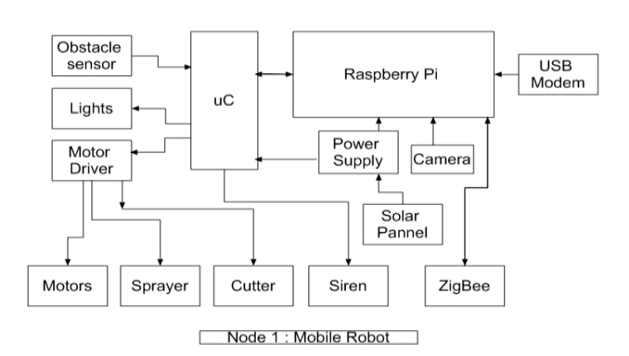

Node 2: Node2 will be the warehouse. It consists of motion detector, light sensor, humidity sensor, temperature sensor, room heater, cooling fan altogether interfaced with AVR microcontroller. Motion detector will detect the motion in the room when security mode will be ON and on detection of motion, it will send the alert signal to user via Raspberry pi and thus providing theft detection. Temperature sensor and Humidity sensor senses the temperature and humidity respectively and if the value crosses the threshold then room heater or cooling fan will be switched ON/OFF automatically providing temperature and humidity maintenance.Node2 will also controls water pump depending upon the soil moisture data sent by node3.

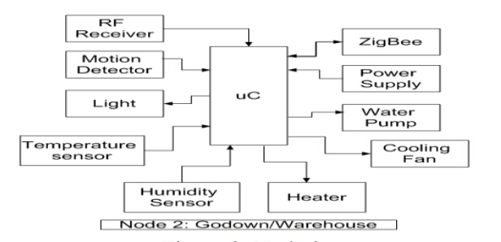

Node 3: Node3 is a smart irrigation node with features like ; Smart control of water pump based on real time field data i.e. automatically turning on/off the pump after attaining the required soil moisture level in auto mode, Switching water pump on/off remotely via mobile or computer in manual mode, and continuous monitoring of soil moisture. In node3, moisture sensor transmits the data using HT12E Encoder IC and a RF transmitter. The transmitted data is received by node2 and there it is processed by microcontroller in order to control the operation of water pump.

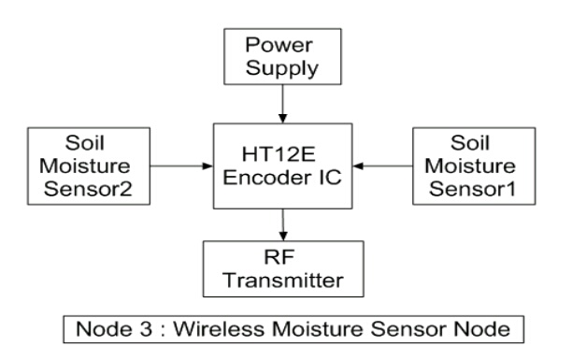

**3.4.3 Flow of algorithm**

The system will start its functioning as the user validation will occur with correct username and password. If username and password, neither of them matches, then the system will terminate. If username exists and the password is correct then the initialization of the system will take place, by initialization, it means that all the sensors in the field such as temperature sensor, soil moisture sensor, water level indicator sensor, rain detector sensor will be initialized to zero, hence refreshing the memory including data or archived values if any displayed. The data thus sensed by the sensors i.e temperature of the environment, soil moisture content, water level, possibility of rain, all these factors are sensed will be collected and transferred to the base server station located in the field. The base server station will further transfer the data to the central server system over a reliable protocol. The central server station will analyze the data sent by the base server station based on the threshold values set for each entity. The analyzed data will then be displayed to the user. Based on this result, the farmer can take the decisions accordingly which are favourable for the efficient farming. if the user(farmer) wishes to continue with the system data then instead of exiting it will tell the system to continue and the sensors will be initialized again repeating the whole cycle again. If the user is satisfied and wants to exit the system, then the user will exit and the system will terminate.

All the available activities well as central system, Base station and Data analysis these entities are enlisted which are key entities of the architecture. How this algorithm works can be better understood by looking at snapshots of GUIs which will show the options available for user.

The above snapshot shows the overall layout of the system. The access of the system is secured through a username and password provided to the user. Therefore the data and notices will be only accessible by the valid user. When user is logged in to the system, the GUI (Graphical User Interface) will provide options to the user for next activity. Live monitoring of the farm, previous reports or last notifications can be viewed from the application. In case of any query it provides option for Help.

**3.4.4 Hardware used:**

a) AVR Microcontroller Atmega 16/32: The microcontroller used is, Low-power AVR® 8-bit Microcontroller, having 8K Bytes of In-System Self programmable Flash program memory, Programmable Serial USART, 8-channel, 10-bit ADC, 23 Programmable I/O Lines.

b) ZigBee Module: ZigBee is used for achieving wireless communication between Node1 and Node2. The range for Zigbee is roughly 50 meters and it can be increased using high power modules or by using network of modules. It operates on 2.4 GHz frequency. Its power consumption is very low and it is less expensive as compared to other wireless modules like Wi-Fi or Bluetooth. It is usually used to establish wireless local area networks.

c) Temperature Sensor LM35: The LM35 is precision IC temperature sensor. Output voltage of LM35 is directly proportional to the Centigrade/Celsius of temperature. The LM35 does not need external calibration or trimming to provide accurate temperature range. It is very low cost sensor. It has low output impedance and linear output. The operating temperature range for LM35 is −55˚ to +150˚C. With rise in temperature, the output voltage of the sensor increases linearly and the value of voltage is given to the microcontroller which is multiplied by the conversion factor in order to give the value of actual temperature.

d) Moisture sensor: Soil moisture sensor measures the water content in soil. It uses the property of the electrical resistance of the soil. The relationship among the measured property and soil moisture is calibrated and it may vary depending on environmental factors such as temperature, soil type, or electric conductivity. Here, It is used to sense the moisture in field and transfer it to microcontroller in order to take controlling action of switching water pump ON/OFF.

Humidity sensor: The DHT11 is a basic, low-cost digital temperature and humidity sensor. It gives out digital value and hence there is no need to use conversion algorithm at ADC of the microcontroller and hence we can give its output directly to data pin instead of ADC. It has a capacitive sensor for measuring humidity. The only real shortcoming of this sensor is that one can only get new data from it only after every 2 seconds.

e) Obstacle sensor (Ultra-Sonic): The ultra-sonic sensor operates on the principle of sound waves and their reflection property. It has two parts; ultrasonic transmitter and ultra-sonic receiver. Transmitter transmits the 40 KHz sound wave and receiver receives the reflected 40 KHz wave and on its reception, it sends the electrical signal to the microcontroller. The speed of sound in air is already known. Hence from time required to receive back the transmitted sound wave, the distance of obstacle is calculated. Here, it is used for obstacle detection in case of mobile robot and as a motion detector in ware house for preventing thefts. The ultra-sonic sensor enables the robot to detect and avoid obstacles and also to measure the distance from the obstacle. The range of operation of ultra-sonic sensor is 10 cm to 30 cm.

f) Raspberry Pi : The Raspberry Pi is small pocket size computer used to do small computing and networking operations. It is the main element in the field of internet of things. It provides access to the internet and hence the connection of automation system with remote location controlling device becomes possible. Raspberry Pi is available in various versions. Here, model Pi 2 model B is used and it has quad-core ARM Cortex-A53 CPU of 900 MHz, and RAM of 1GB. it also has: 40 GPIO pins, Full HDMI port, 4 USB ports, Ethernet port, 3.5mm audio jack, video Camera interface (CSI), the Display interface (DSI), and Micro SD card slot.

**3.4.5 Softwares used:**

a) AVR Studio Version 4: It is used to write, build, compile and debug the embedded c program codes which are needed to be burned in the microcontroller in order to perform desired operations. This software directly provides .hex file which can be easily burned into the microcontroller.

b) Proteus 8 Simulator: Proteus 8 is one of the best simulation software for various circuit designs of microcontroller. It has almost all microcontrollers and electronic components readily available in it and hence it is widely used simulator. It can be used to test programs and embedded designs for electronics before actual hardware testing. The simulation of programming of microcontroller can also be done in Proteus. Simulation avoids the risk of damaging hardware due to wrong design.

c) Dip Trace: Dip race is EDA/CAD software for creating schematic diagrams and printed circuit boards. The developers provide multi-lingual interface and tutorials (currently available in English and 21 other languages). DipTrace has 4 modules: Schematic Capture Editor, PCB Layout Editor with built-in shape-based auto router and 3D Preview & Export, Component Editor, and Pattern Editor.

d) SinaProg: SinaProg is a Hex downloader application with AVR Dude and Fuse Bit Calculator. This is used to download code/program and to set fuse bits of all AVR based microcontrollers.

e) Raspbian Operating System: Raspbian operating system is the free and open source operating system which Debian based and optimized for Raspberry Pi. It provides the basic set of programs and utilities for operating Raspberry Pi. It comes with around 35,000 packages which are pre-compiled softwares that are bundled in a nice format for hustle free installation on Raspberry Pi.It has good community of developers which runs the discussion forms and provides solutions to many relevant problems. However, Raspbian OS is still under consistent development with a main focus on improving the performance and the stability of as many Debian packages as possible.

**3.5 Excising System:**

The European Commission has provided substantial support to developing Internet of Things research, e.g. in so-called the Future Internet programme. In the agricultural field, FIspace has been the focal point of this work.

To ensure significant progress in the envisioned Large Scale Pilot, we propose to build on the results of FIspace. It mitigates the needs and limitations discussed previously in various ways.

FIspace1 provides a multi-domain cloud-based platform, following the Software-as-aService (SaaS) delivery model, in which ICT developers can easily develop smart software application services (‘Apps’) based on FIWARE2 GEs. These Apps should collaborate seamlessly together to support business control processes. Because FIspace is not intended to replace existing information systems but rather to link them together smoothly, actual data and information systems are placed outside the FIspace platform.

The lowest layer – the IoT layer - is where object sensing and actuating takes place, generating data from objects in the food supply chain. The objects are being virtualized and put in the system & data integration module of FIspace. The upper layer is the application service layer where services are offered to the supply chain users to support business process control leveraged by apps from the FIspace App store. The B2B collaboration core enables apps to work together in a seamless and real-time manner. All communication goes through the security, privacy and trust (SPT) framework layer. The Apps are accessed through a User Front-End that consists of a configurable graphical user interface so that Apps can be located at different points (Smartphone, machine terminal, bar code reader, etc.). The interaction between all modules is handled by an Operating Environment which ensures the technical interoperability and communication of (distributed) FIspace components and Apps and the consistent behaviour of FIspace as a whole. A Software Development Toolkit (SDK) provides tool-support for the development of Apps.

A software ecosystem can be formed consisting of:

* supply chain actors or end users (farmers, technology providers, processors, etc.)
* app developers
* service providers
* infrastructure providers that facilitate the platform

The great benefit of this approach is that supply chain actors are collaborating through the platform and the corresponding apps and services are working seamlessly together. For example if a farmer is supplying a local food web with products he has to comply with certain standards for which he can use a compliance service. He can use the same compliance service probably to deliver his products to another market. The data that are involved in this process are provided by several apps that are connected with through virtual objects with the real production processes on and around the farm. App and service providers can focus on particular services and for a great deal rely on the general infrastructure of the FIspace platform. Apps can come from different independent vendors and also easily be replaced by others. This will lead to lower costs for development and ultimately more affordable services for end users.

A few example projects :

* All plant protection systems based on remote sensing and on forecasting software (+ wireless sensors), especially in viticulture and horticulture
* Crop rotation planners a for arable crops taking into account soil fertility and health, carbon balancing as well as changing demands from supply chain
* Sensors (cameras, optic tools) for mechanical weed management for arable and vegetable production, while allowing for the different needs in different sectors
* Flexible soil management and mulching in permanent crops within and between rows – regulated by humidity, growth of crop and by-plants (weeds and companion plants), possibly as further developed agro forestry systems.
* Optimization of health and welfare of animals and product quality in animal production (e.g. milk production) with further developed sensor and actuators.
* Optimization of product nutritional and sensorial quality from field to plate in the supply chain.
* Software for improved traceability of organic products or AOC products (especially wines, but also for other high value products)
* Smart (sustainability) shopping tools linking specific product with information on sustainability aspects of the product and its origin linked to personal preferences.

**CHAPTER 4**

**IMPLEMENTATION**

In this chapter we describe the technologies, the equipment, and the architecture that have been used to develop our model system. The implementation of the designed system is described. Additionally, the development process is described with details of the form of the different versions of the prototype that we created along with the changes that took place during the development process. This system was designed based upon consideration of a number of fundamental constraints regarding the resource constrained environments that it would we likely be applied in Furthermore, such a system should be developed while ca are fully considering some fundamental design constraints.

BLOCK DIAGRAM

**4.1 Hardware Required:**

* ARDUINO
* TEMPERATURE SENSOR
* HEART BEATSENSOR
* MEMS SENSOR
* WIFI MODULE

**4.2 Software Required:**

* ARDUINO IDE

**4.3Arduino**

The Arduino Uno is a microcontroller board based on the ATmega328. It has 14 digital Input/output pins (of which 6 can be used as PWM outputs), 6 analog inputs, a 16 MHz crystal oscillator, a USB connection, a power jack, an ICSP header, and a reset button. It contains everything needed to Support the microcontroller; simply connect it to a computer with a USB cable or power it with a AC-to-DC adapter or battery to get started. The Uno differs from all preceding boards in that it does not use the FTDI USB-to-serial driver chip. The Uno and version 1.0will be the reference versions of Arduno, moving forward. The Uno is the latest in a series of USB Arduino boards, and the reference model for the Arduino platform; for a comparison with previous versions

**TECHNICAL SPECIFICATION**

* Microcontroller AT mega 328
* Operating Voltage 5V
* Input Voltage (recommended) 7-12V
* Input Voltage (limits) 6-20V
* Digital I/O Pins 14 (of which 6 provide PWM output)
* Analog Input Pins 6
* DC Current per I/O Pin 40 mA
* DC Current for 3.3V Pin 50 mA
* Flash Memory 32 KB ofwhich0.5
* KB used by Boot loader
* SRAM 2 KB
* EEPROM 1 KB
* Clock Speed 16 MHz

4.4 **TEMPERATURE SENSOR LM35**

**Range and Accuracy**

The LM35 measures a temperature range of -55 to 150 degrees Celsius. It produces an analog voltage signal that has a linear relationship to temperature, with a scale of 10.0 mV per degree Celsius. At room temperature, the LM35 has a typical accuracy of plus or minus 0.25 degrees Celsius, and plus or minus 0.75 degrees Celsius over the full temperature range. In still air, it takes three minutes for the output to reach its final value; at one minute, the output is about 70 percent of the value.

**Voltage and Current**

The sensor normally takes a supply voltage of either 5 or 10 volts, but it can accept a supply voltage ranging from 4 to 30 volts. The LM35 draws only 60 uA of current from a single or bipolar power supply. If you use a single supply voltage, the chip will measure temperatures from 0 to 150 degrees Celsius, where 0 degrees outputs 0 V and 150 degrees outputs 1,500 mV.

**FEATURES**

* Calibrated directly in ° Celsius (Centigrade)
* Linear + 10.0 mV/°C scale factor
* 0.5°C accuracy guarantee able (at +25°C)
* Rated for full −55° to +150°C range
* Suitable for remote applications
* Low cost due to wafer-level trimming
* Operates from 4 to 30 volts
* Less than 60 μA current drain
* Low self-heating, 0.08°C in still air
* Nonlinearity only ±1⁄4°C typical
* Low impedance output, 0.1 W for 1 mA load

**MEMS SENSOR:**

An **accelerometer** is a device that measures proper acceleration ("g-force"). Proper acceleration is not the same as coordinate acceleration (rate of change of velocity). For example, an accelerometer at rest on the surface of the Earth will measure an acceleration g= 9.81 m/s2 straight upwards. By contrast, accelerometers in free fall (falling toward the center of the Earth at a rate of about 9.81 m/s2) will measure zero.

Accelerometers have multiple applications in industry and science. Highly sensitive accelerometers are components of inertial navigation systems for aircraft and missiles. Accelerometers are used to detect and monitor vibration in rotating machinery. Accelerometers are used in tablet computers and digital cameras so that images on screens are always displayed upright. Accelerometers are used in drones for flight stabilisation. Pairs of accelerometers extended over a region of space can be used to detect differences (gradients) in the proper accelerations of frames of references associated with those points.These devices are called gravity gradiometers, as they measure gradients in the gravitational field. Such pairs of accelerometers in theory may also be able to detect gravitational waves.

**ESP8266-12E WIFI MODULE**

**Description**

ESP-12E is a low power consumption of the UART-WiFi module, with very competitive prices in the industry and ultralow power consumption technology, designed specifically for mobile devices and IOT applications, user's physical devicecan be connected to a Wi-Fi wireless network, Internet or intranet communication and networking capabilities. ESP-07 theuse of small ceramic antenna package can support IPEX interface. users have a variety of installation options.

**Features**

* ▪ 802.11 b/g/n protocol
* ▪ Wi-Fi Direct (P2P), soft-AP
* ▪ Integrated TCP/IP protocol stack
* ▪ +19.5dBm output power in 802.11b mode
* ▪ Power down leakage current of < 10uA
* ▪ Integrated low power 32-bit MCU
* ▪ SDIO 2.0, SPI, UART
* ▪ STBC, 1x1 MIMO, 2x1 MIMO
* ▪ A-MPDU & A-MSDU aggregation & 0.4μs guard interval
* ▪ Wake up and transmit packets in < 2ms
* ▪ Standby power consumption of < 1.0mW (DTIM3)

**HEART RATE/PULSE SENSOR**

Heart beat sensor is designed to give digital output of heat beat when a thumb finger is placed between the LDR & LED on it. When the heart beat detector is working, the beat LED flashes in unison with each heart beat. This digital output can be connected to microcontroller directly to measure the Beats Per Minute (BPM) rate. It works on the principle of light modulation by blood flow through finger at each pulse.

The Heart Rate sensor monitors the light level transmitted through the vascular tissue of the fingertip and the corresponding variations in light intensities that occur as the blood volume change in the tissue. The ease of use makes it possible to measure everyone's heart rate, even in large classes.

The Heart Rate sensor measures heart rate between 0 and 200 bpm (beats per minute).

**FEATURES**

* Output digital signal for directly connecting to microcontroller
* Heat beat indication by LED
* Compact size
* Working voltage +5v dc

**DESCRIPTIONS**

The Heart Rate sensor can be connected to the NOVA5000, NOVA LINK or Multi LogPRO data loggers.The Heart Rate sensor monitors the light level transmitted through the vascular tissue of the fingertip and the corresponding variations in light intensities that occur as the blood volume change in the tissue. The ease of use makes it possible to measure everyone's heart rate, even in large classes.

Unlike an electrocardiograph (EKG) which monitors the electrical signal of the heart, the Heart Rate sensor measures heart rate by monitoring the change in infrared transmittance through blood vessels. As the heart forces blood through the blood vessels, the amount of blood changes with time and the corresponding variation in light intensities changes. By plotting this signal, the heart rate can be determined

**Transformerless Power Supplies**

Transformerless AC power supply theory is not generally taught at the university level, yet the use of such power supplies is prevalent in consumer goods.

**Basic Concept**

A transformerless power supply typically incorporates:

* Rectification
* Voltage Division
* Regulation
* Filtering
* Inrush Limiting

**4.9 Source Code**

<?xml version="1.0" encoding="utf-8"?>

<manifest xmlns:"http://schemas.android.com/apk/res/android" android:versionCode="1" android:versionName="1.0" package="com.prop.iotsensor">

<uses-sdk android:minSdkVersion="14" android:targetSdkVersion="18" />

<uses-permission android:name="android.permission.INTERNET" />

<uses-permission android:name="android.permission.ACCESS_NETWORK_STATE" />

<uses-permission android:name="android.permission.ACCESS_WIFI_STATE" />

<uses-permission android:name="android.permission.READ_PHONE_STATE" />

<uses-permission android:name="android.permission.ACCESS_FINE_LOCATION" />

<uses-permission android:name="android.permission.ACCESS_MOCK_LOCATION" />

<uses-permission android:name="android.permission.ACCESS_COARSE_LOCATION" />

<uses-permission android:name="com.google.android.providers.gsf.permission.READ_GSERVICES" />

<uses-permission android:name="android.permission.WRITE_EXTERNAL_STORAGE" />

<application android:theme="@style/AppTheme" android:label="@string/app_name" android:icon="@drawable/ioticon" android:debuggable="true" android:allowBackup="true">

<activity android:label="@string/app_name" android:name="com.prop.iotsensor.HomePage">

<intent-filter>

<action android:name="android.intent.action.MAIN" />

<category android:name="android.intent.category.LAUNCHER" />

</intent-filter>

</activity>

<activity android:name=".SensorActivity" />

<activity android:name=".ViewSensor" />

<activity android:name=".MainActivity2" />

<activity android:name=".CropView" />

<activity android:name=".CropViewMain" />

<activity android:name=".CropView1" />

<activity android:name=".CropView11" />

<activity android:name=".CropView12" />

<activity android:name=".CropView2" />

<activity android:name=".CropView21" />

<activity android:name=".CropView22" />

<activity android:name=".MarketPrice" />

<activity android:name=".MarketPrice1" />

<activity android:name=".MarketPrice11" />

<activity android:name=".MarketPrice12" />

<activity android:name=".MarketPrice13" />

<activity android:name=".MarketPrice14" />

<activity android:name=".AgriView" />

<activity android:name=".AgriView1" />

<activity android:name=".AgriView11" />

<activity android:name=".AgriView12" />

<activity android:name=".AgriView13" />

<activity android:name=".AgriView14" />

<activity android:name=".AgriView15" />

<activity android:name=".AgriView16" />

<activity android:name=".AgriView17" />

<activity android:name=".AgriView18" />

<activity android:name=".AgriView19" />

<activity android:name=".AgriView20" />

</application>

</manifest>

**Acessibility service**

package android.support.v4.accessibilityservice;

import android.accessibilityservice.AccessibilityServiceInfo;

import android.content.pm.ResolveInfo;

import android.os.Build.VERSION;

public class AccessibilityServiceInfoCompat {

public static final int CAPABILITY_CAN_FILTER_KEY_EVENTS = 8;

public static final int CAPABILITY_CAN_REQUEST_ENHANCED_WEB_ACCESSIBILITY = 4;

public static final int CAPABILITY_CAN_REQUEST_TOUCH_EXPLORATION = 2;

public static final int CAPABILITY_CAN_RETRIEVE_WINDOW_CONTENT = 1;

public static final int DEFAULT = 1;

public static final int FEEDBACK_ALL_MASK = -1;

public static final int FEEDBACK_BRAILLE = 32;

public static final int FLAG_INCLUDE_NOT_IMPORTANT_VIEWS = 2;

public static final int FLAG_REPORT_VIEW_IDS = 16;

public static final int FLAG_REQUEST_ENHANCED_WEB_ACCESSIBILITY = 8;

public static final int FLAG_REQUEST_FILTER_KEY_EVENTS = 32;

public static final int FLAG_REQUEST_TOUCH_EXPLORATION_MODE = 4;

private static final AccessibilityServiceInfoVersionImpl IMPL;

interface AccessibilityServiceInfoVersionImpl {

boolean getCanRetrieveWindowContent(AccessibilityServiceInfo accessibilityServiceInfo);

int getCapabilities(AccessibilityServiceInfo accessibilityServiceInfo);

String getDescription(AccessibilityServiceInfo accessibilityServiceInfo);

String getId(AccessibilityServiceInfo accessibilityServiceInfo);

ResolveInfo getResolveInfo(AccessibilityServiceInfo accessibilityServiceInfo);

String getSettingsActivityName(AccessibilityServiceInfo accessibilityServiceInfo);

}

static class AccessibilityServiceInfoStubImpl implements AccessibilityServiceInfoVersionImpl {

AccessibilityServiceInfoStubImpl() {

}

public boolean getCanRetrieveWindowContent(AccessibilityServiceInfo info) {

return false;

}

public String getDescription(AccessibilityServiceInfo info) {

return null;

}

public String getId(AccessibilityServiceInfo info) {

return null;

}

public ResolveInfo getResolveInfo(AccessibilityServiceInfo info) {

return null;

}

public String getSettingsActivityName(AccessibilityServiceInfo info) {

return null;

}

public int getCapabilities(AccessibilityServiceInfo info) {

return 0;

}

}

static class AccessibilityServiceInfoIcsImpl extends AccessibilityServiceInfoStubImpl {

AccessibilityServiceInfoIcsImpl() {

}

public boolean getCanRetrieveWindowContent(AccessibilityServiceInfo info) {

return AccessibilityServiceInfoCompatIcs.getCanRetrieveWindowContent(info);

}

public String getDescription(AccessibilityServiceInfo info) {

return AccessibilityServiceInfoCompatIcs.getDescription(info);

}

public String getId(AccessibilityServiceInfo info) {

return AccessibilityServiceInfoCompatIcs.getId(info);

}

public ResolveInfo getResolveInfo(AccessibilityServiceInfo info) {

return AccessibilityServiceInfoCompatIcs.getResolveInfo(info);

}

public String getSettingsActivityName(AccessibilityServiceInfo info) {

return AccessibilityServiceInfoCompatIcs.getSettingsActivityName(info);

}

public int getCapabilities(AccessibilityServiceInfo info) {

if (getCanRetrieveWindowContent(info)) {

return AccessibilityServiceInfoCompat.DEFAULT;

}

return 0;

}

}

static class AccessibilityServiceInfoJellyBeanMr2 extends AccessibilityServiceInfoIcsImpl {

AccessibilityServiceInfoJellyBeanMr2() {

}

public int getCapabilities(AccessibilityServiceInfo info) {

return AccessibilityServiceInfoCompatJellyBeanMr2.getCapabilities(info);

}

}

static {

if (VERSION.SDK_INT >= 18) {

IMPL = new AccessibilityServiceInfoJellyBeanMr2();

} else if (VERSION.SDK_INT >= 14) {

IMPL = new AccessibilityServiceInfoIcsImpl();

} else {

IMPL = new AccessibilityServiceInfoStubImpl();

}

}

private AccessibilityServiceInfoCompat() {

}

public static String getId(AccessibilityServiceInfo info) {

return IMPL.getId(info);

}

public static ResolveInfo getResolveInfo(AccessibilityServiceInfo info) {

return IMPL.getResolveInfo(info);

}

public static String getSettingsActivityName(AccessibilityServiceInfo info) {

return IMPL.getSettingsActivityName(info);

}

public static boolean getCanRetrieveWindowContent(AccessibilityServiceInfo info) {

return IMPL.getCanRetrieveWindowContent(info);

}

public static String getDescription(AccessibilityServiceInfo info) {

return IMPL.getDescription(info);

}

public static String feedbackTypeToString(int feedbackType) {

StringBuilder builder = new StringBuilder();

builder.append("[");

while (feedbackType > 0) {

int feedbackTypeFlag = DEFAULT << Integer.numberOfTrailingZeros(feedbackType);

feedbackType &= feedbackTypeFlag ^ FEEDBACK_ALL_MASK;

if (builder.length() > DEFAULT) {

builder.append(", ");

}

switch (feedbackTypeFlag) {

case DEFAULT /*1*/:

builder.append("FEEDBACK_SPOKEN");

break;

case FLAG_INCLUDE_NOT_IMPORTANT_VIEWS /*2*/:

builder.append("FEEDBACK_HAPTIC");

break;

case FLAG_REQUEST_TOUCH_EXPLORATION_MODE /*4*/:

builder.append("FEEDBACK_AUDIBLE");

break;

case FLAG_REQUEST_ENHANCED_WEB_ACCESSIBILITY /*8*/:

builder.append("FEEDBACK_VISUAL");

break;

case FLAG_REPORT_VIEW_IDS /*16*/:

builder.append("FEEDBACK_GENERIC");

break;

default:

break;

}

}

builder.append("]");

return builder.toString();

}

public static String flagToString(int flag) {

switch (flag) {

case DEFAULT /*1*/:

return "DEFAULT";

case FLAG_INCLUDE_NOT_IMPORTANT_VIEWS /*2*/:

return "FLAG_INCLUDE_NOT_IMPORTANT_VIEWS";

case FLAG_REQUEST_TOUCH_EXPLORATION_MODE /*4*/:

return "FLAG_REQUEST_TOUCH_EXPLORATION_MODE";

case FLAG_REQUEST_ENHANCED_WEB_ACCESSIBILITY /*8*/:

return "FLAG_REQUEST_ENHANCED_WEB_ACCESSIBILITY";

case FLAG_REPORT_VIEW_IDS /*16*/:

return "FLAG_REPORT_VIEW_IDS";

case FLAG_REQUEST_FILTER_KEY_EVENTS /*32*/:

return "FLAG_REQUEST_FILTER_KEY_EVENTS";

default:

return null;

}

}

public static int getCapabilities(AccessibilityServiceInfo info) {

return IMPL.getCapabilities(info);

}

public static String capabilityToString(int capability) {

switch (capability) {

case DEFAULT /*1*/:

return "CAPABILITY_CAN_RETRIEVE_WINDOW_CONTENT";

case FLAG_INCLUDE_NOT_IMPORTANT_VIEWS /*2*/:

return "CAPABILITY_CAN_REQUEST_TOUCH_EXPLORATION";

case FLAG_REQUEST_TOUCH_EXPLORATION_MODE /*4*/:

return "CAPABILITY_CAN_REQUEST_ENHANCED_WEB_ACCESSIBILITY";

case FLAG_REQUEST_ENHANCED_WEB_ACCESSIBILITY /*8*/:

return "CAPABILITY_CAN_FILTER_KEY_EVENTS";

default:

return "UNKNOWN";

}

}

}

package android.support.v4.accessibilityservice;

import android.accessibilityservice.AccessibilityServiceInfo;

import android.content.pm.ResolveInfo;

class AccessibilityServiceInfoCompatIcs {

AccessibilityServiceInfoCompatIcs() {

}

public static boolean getCanRetrieveWindowContent(AccessibilityServiceInfo info) {

return info.getCanRetrieveWindowContent();

}

public static String getDescription(AccessibilityServiceInfo info) {

return info.getDescription();

}

public static String getId(AccessibilityServiceInfo info) {

return info.getId();

}

public static ResolveInfo getResolveInfo(AccessibilityServiceInfo info) {

return info.getResolveInfo();

}

public static String getSettingsActivityName(AccessibilityServiceInfo info) {

return info.getSettingsActivityName();

}

}

package android.support.v4.accessibilityservice;

import android.accessibilityservice.AccessibilityServiceInfo;

class AccessibilityServiceInfoCompatJellyBeanMr2 {

AccessibilityServiceInfoCompatJellyBeanMr2() {

}

public static int getCapabilities(AccessibilityServiceInfo info) {

return info.getCapabilities();

}

}

**Database**

package android.support.v4.database;

import android.text.TextUtils;

public class DatabaseUtilsCompat {

private DatabaseUtilsCompat() {

}

public static String concatenateWhere(String a, String b) {

if (TextUtils.isEmpty(a)) {

return b;

}

if (TextUtils.isEmpty(b)) {

return a;

}

return "(" + a + ") AND (" + b + ")";

}

public static String[] appendSelectionArgs(String[] originalValues, String[] newValues) {

if (originalValues == null || originalValues.length == 0) {

return newValues;

}

String[] result = new String[(originalValues.length + newValues.length)];

System.arraycopy(originalValues, 0, result, 0, originalValues.length);

System.arraycopy(newValues, 0, result, originalValues.length, newValues.length);

return result;

}

}

**Hardware**

package android.support.v4.hardware.display;

import android.content.Context;

import android.os.Build.VERSION;

import android.view.Display;

import android.view.WindowManager;

import java.util.WeakHashMap;

public abstract class DisplayManagerCompat {

public static final String DISPLAY_CATEGORY_PRESENTATION = "android.hardware.display.category.PRESENTATION";

private static final WeakHashMap<Context, DisplayManagerCompat> sInstances;

private static class JellybeanMr1Impl extends DisplayManagerCompat {

private final Object mDisplayManagerObj;

public JellybeanMr1Impl(Context context) {

this.mDisplayManagerObj = DisplayManagerJellybeanMr1.getDisplayManager(context);

}

public Display getDisplay(int displayId) {

return DisplayManagerJellybeanMr1.getDisplay(this.mDisplayManagerObj, displayId);

}

public Display[] getDisplays() {

return DisplayManagerJellybeanMr1.getDisplays(this.mDisplayManagerObj);

}

public Display[] getDisplays(String category) {

return DisplayManagerJellybeanMr1.getDisplays(this.mDisplayManagerObj, category);

}

}

private static class LegacyImpl extends DisplayManagerCompat {

private final WindowManager mWindowManager;

public LegacyImpl(Context context) {

this.mWindowManager = (WindowManager) context.getSystemService("window");

}

public Display getDisplay(int displayId) {

Display display = this.mWindowManager.getDefaultDisplay();

return display.getDisplayId() == displayId ? display : null;

}

public Display[] getDisplays() {

return new Display[]{this.mWindowManager.getDefaultDisplay()};

}

public Display[] getDisplays(String category) {

return category == null ? getDisplays() : new Display[0];

}

}

public abstract Display getDisplay(int i);

public abstract Display[] getDisplays();

public abstract Display[] getDisplays(String str);

static {

sInstances = new WeakHashMap();

}

DisplayManagerCompat() {

}

public static DisplayManagerCompat getInstance(Context context) {

DisplayManagerCompat instance;

synchronized (sInstances) {

instance = (DisplayManagerCompat) sInstances.get(context);

if (instance == null) {

if (VERSION.SDK_INT >= 17) {

instance = new JellybeanMr1Impl(context);

} else {

instance = new LegacyImpl(context);

}

sInstances.put(context, instance);

}

}

return instance;

}

}

package android.support.v4.hardware.display;

import android.content.Context;

import android.hardware.display.DisplayManager;

import android.view.Display;

final class DisplayManagerJellybeanMr1 {

DisplayManagerJellybeanMr1() {

}

public static Object getDisplayManager(Context context) {

return context.getSystemService("display");

}

public static Display getDisplay(Object displayManagerObj, int displayId) {

return ((DisplayManager) displayManagerObj).getDisplay(displayId);

}

public static Display[] getDisplays(Object displayManagerObj) {

return ((DisplayManager) displayManagerObj).getDisplays();

}

public static Display[] getDisplays(Object displayManagerObj, String category) {

return ((DisplayManager) displayManagerObj).getDisplays(category);

}

}

**CHAPTER 5**

**ANALYSIS**

**5.1 Analysis**

This chapter presents the purpose of designing the proposed precision healthcare system, the limitations that were faced during the implement, and the evaluation of the system as implemented by the prototype. The decisions that lead to the choices that have been made during the design and implementation of the project are presented in order to give the reader both a storyline of the development of the system and so that these decisions are made explicit (as these decisions might be made differently by others in the future).

**5.2 Design purpose and limitations**

The main goal of designing a precision healthcare system is to introduce additional information and communication technology into monitoring processes in order to enable more effective hospitality, while simultaneous reducing the impact of environment. Designing such a system is not an easy job, since a generic implementation that would work in most of the cases is something that cannot be easily realized.

Following discussions with doctors and scientist, the common outcome in most cases was that it is very difficult to have a generic set of rules that are applicable everywhere. There are distinct aspects that have to be considered for each specific setting. Location of the patient, distance from source(s), inclination, quality of the service, infections, and historic statistics are some of the aspects that have to be considered when a plan is designed and followed. The diversity of local conditions is a major problem in decision making in each case. There could even be differences in a specific place year by year causing variation in the hospital. Even within a range of several meters, differences in conditions can be observed that cause heterogeneity in the resulting production.

The knowledge source to recognize and address these specifics is the users themselves as they apply their service methods over a period of years in custom ways in order to achieve the best results. One of the goals of the system’s design is to allow these users to pass this knowledge on to the system in such a way that the system can enrich its knowledge base. This transfer of knowledge can occur by customizing the system for the specific needs that each user has. By allowing the user to add custom rules for each specific field (more specifically for each part of the field) and for every sensor that is utilized, the knowledge is transferred from the user to the knowledge base of the system*. After using the system for a period of time, historical data can also be accessed in order to retrieve information about past schemes in both specific settings and in a diverse set of settings. Correlating old schemes with the corresponding result can lead to better decision making for future work.

With respect to the sensor platform part of the system, an older prototype platform was initially used as a base. Our first hardware sensor prototype was inherited from Ericsson labs’ project in China. However, the design of the database and web server part of our project started from scratch. Because the time window for this project was limited we sought an initial base and inspiration from other projects. As noted earlier we tried to use the Contiki OS on this first sensor prototype, but found that we were not able to use the Contiki OS because the open-source operating system had not been ported in ATMega168 microcontroller and the size of the IP stack code was too large for this target platform. After spending more than 3 weeks of trying to use Contiki on this prototype, we decided to move forward with a second prototype based upon the Atmel ATMega328 and the firmware we had already developed.

**5.3 Graphical Analysis**

The analysis can be done for the following parameters:

* IoT View
* Temperature analysis
* Heart Beat analysis
* Motion analysis

**5.3.1 IoT View:**

As the talk, the number of companies to help enable their IoT (Internet of Things) ideas. And as a result, we hear about new ideas and solutions that are already solving business challenges with M2M (Machine to Machine) communication. In one of our recent posts, we discussed some of our favourite industrial IoT applications. And today, we want to highlight some of the most compelling IoT applications in another industry. Healthcare in IoT is becoming one of the fastest growing fields (pun intended) within the IoT. Today, more than ever, doctors have to more effectively utilize and conserve their resources. That’s where the need for data comes in, and M2M communication has made the ongoing collection of that info easy. Check out these five wireless sensors in a patient and observation that are making it possible to obtain the meaningful data they’ve been missing out on.

In this project, we are using Internet of Things (IoT). It means that all the collected data will send to GR- Kaede board and it sends to Web portal (Online view) through Ethernet Cable. This monitoring can be done through any devices like Mobile, Tab, Laptops and Phones.

**5.4 Summary of other analysis:**

The proposed technique has many advantages like

* Reducing the risk of electric shocks, deaths due to poisonous creatures in hospital.
* Visual display using LCD display unit.
* All the parameters can view through online in graphical notation.
* Efficient and low cost design.
* Fast response.
* User friendly.

**5.5 Screenshots**

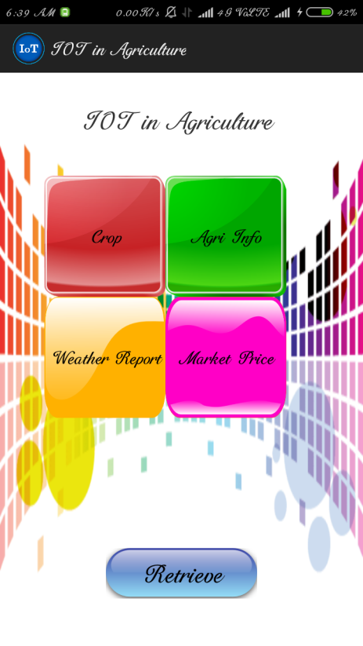

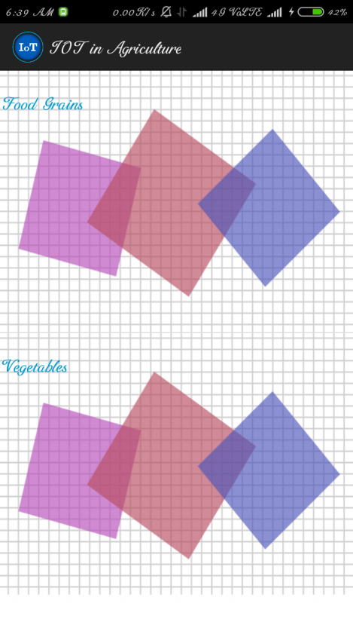

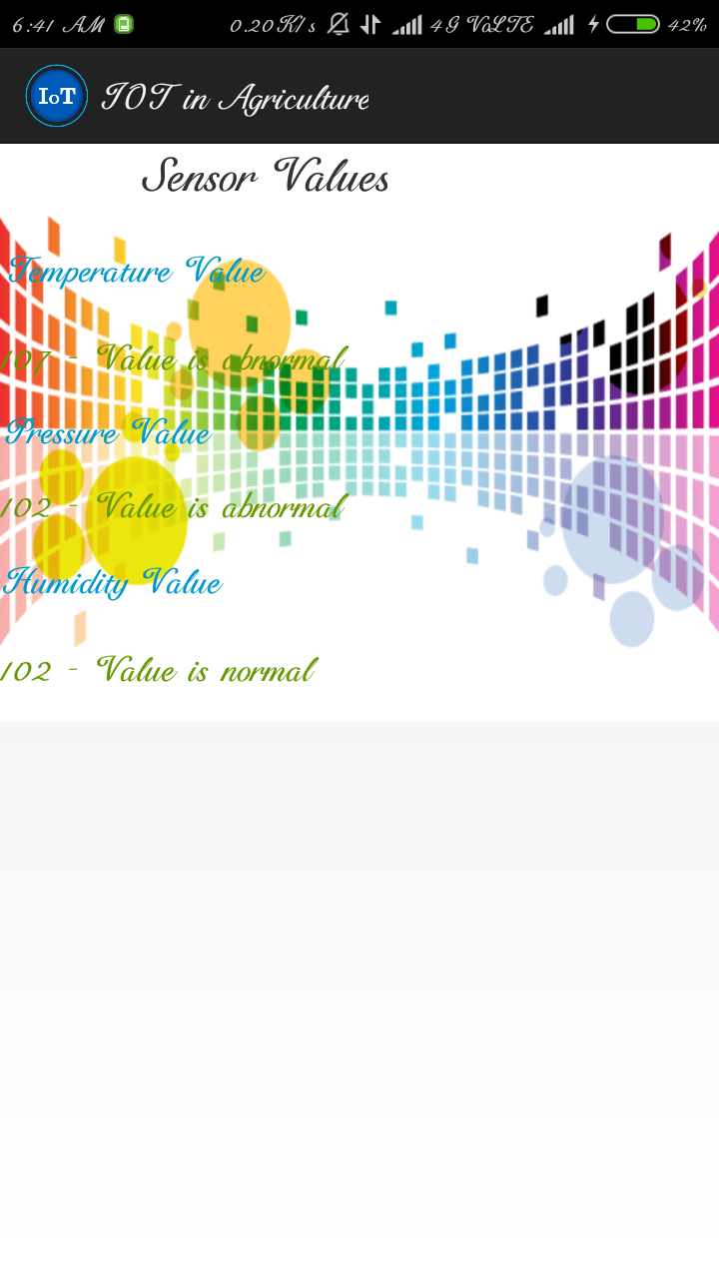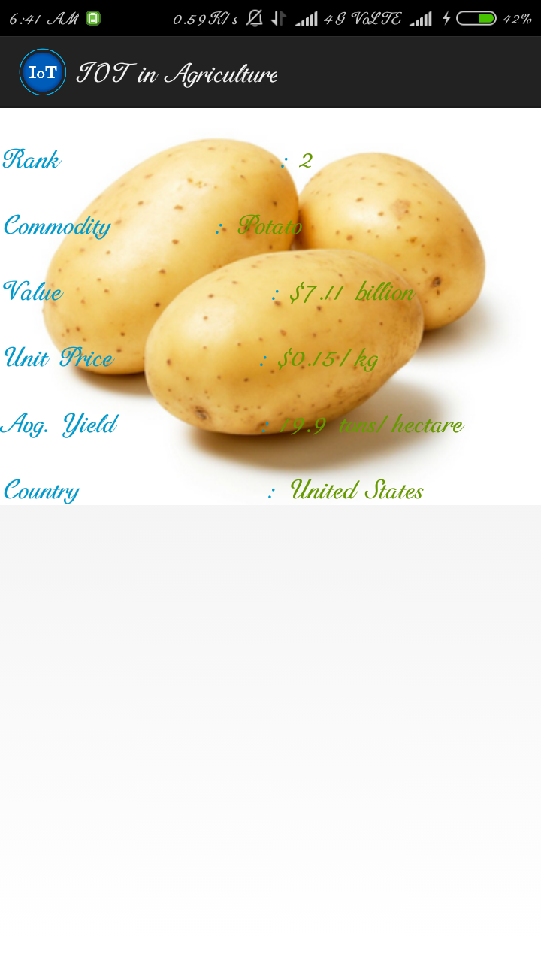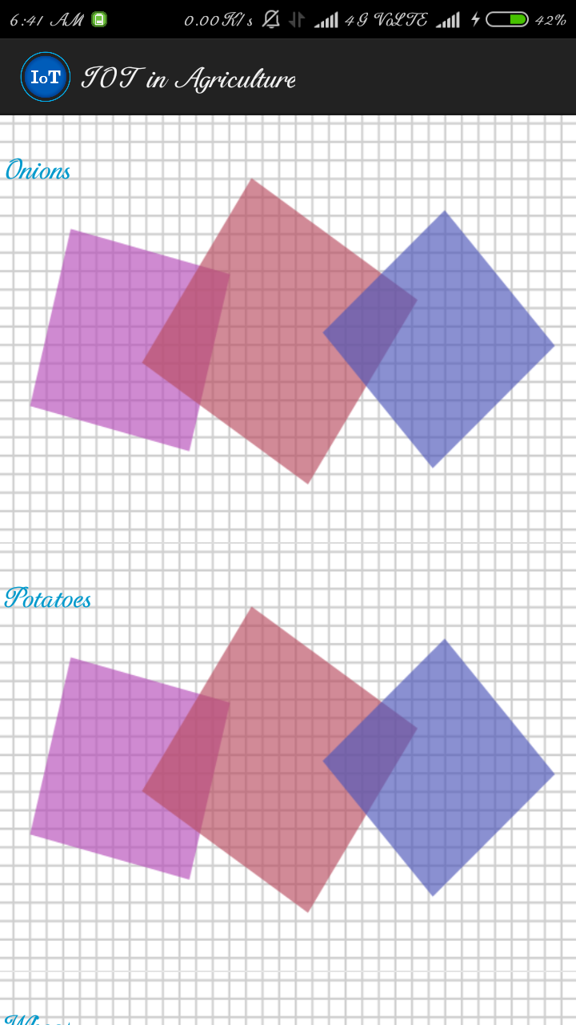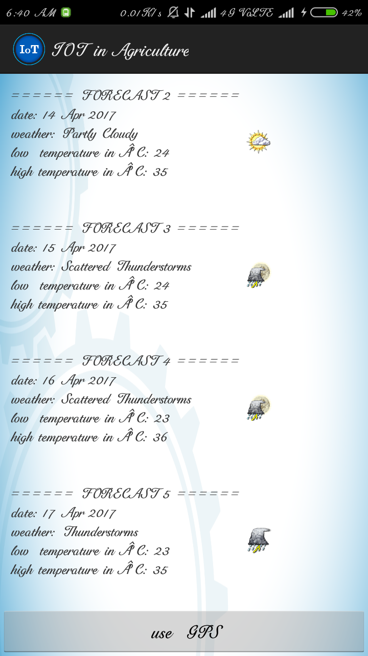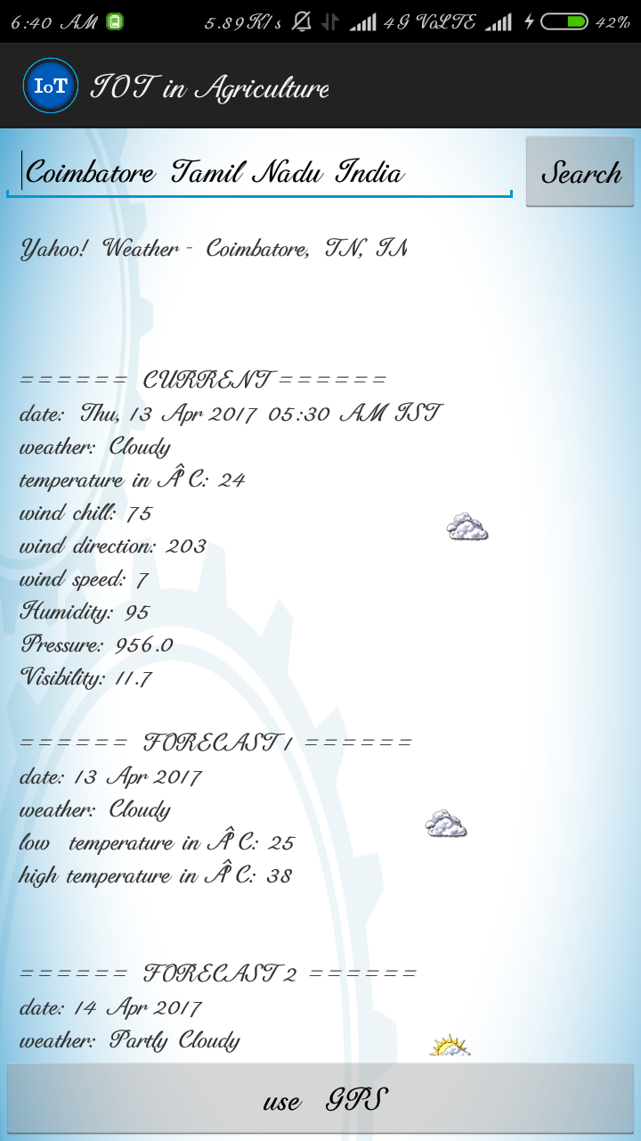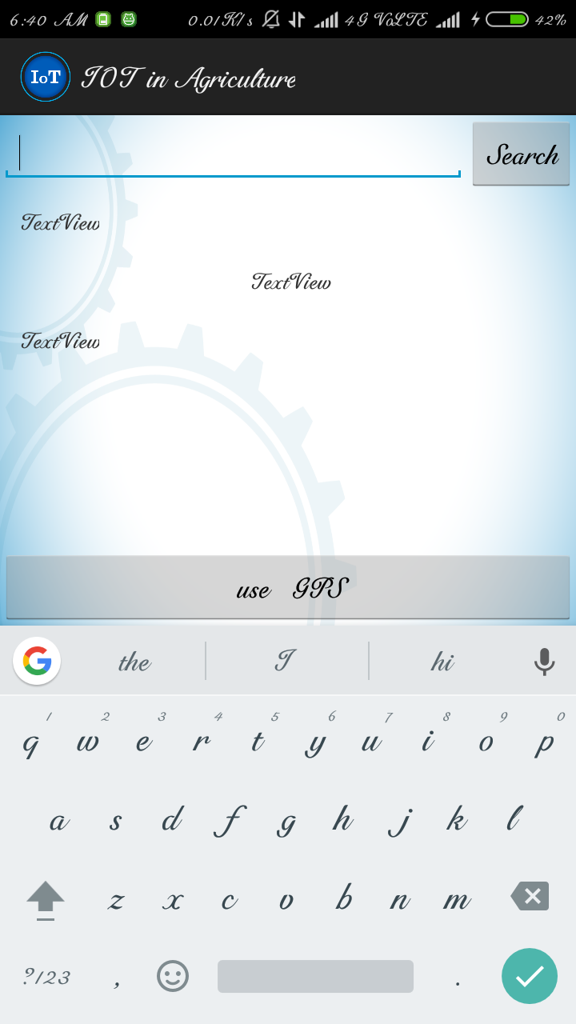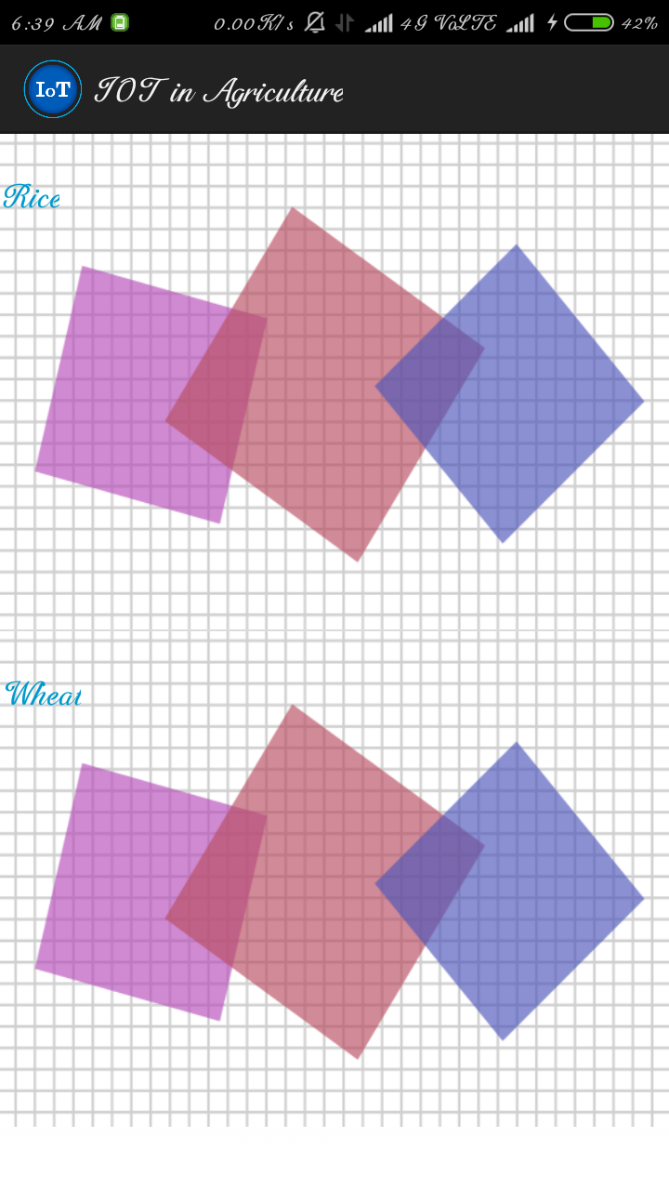

**CHAPTER 6**

**CONCLUSION AND FUTURE WORK**

**6 Conclusions and Future work**

This chapter includes a conclusion of the project along with the jobs that are not in the scope of this thesis and should be done in the future. After the future work, a part that describes the reflections of this project is included.

**6.1 Conclusions**

Conclusion of the future is that IoT becomes a utility with increased sophistication in sensing, actuation, communications, control, and in creating knowledge from vast amounts of data. This will result in qualitatively different lifestyles from today. What the lifestyles would be is anyone‘s guess. It would be fair to say that we cannot predict how lives will change. We did not predict the Internet, the Web, social networking, Facebook, Twitter, millions of apps for smartphones, etc., and these have all qualitatively changed societies lifestyle.

Especially for healthcare system, it is most useful to every human. So health problems are easily predicted at the beginning stage based on IoT healthcare system. In this document, a solution for monitoring patient’s health was presented. The system can act as an early warning system for upcoming threats, a monitoring system constantly reporting on the status. It is claimed that such a system is relevant in the network society and that there is sufficient technical knowledge (software and hardware components, standardized network protocols) to render its implementation not only feasible, but also cost effective.

The objective of smart healthcare through Internet of things to provide low cost solution with high reliability and real time data transfer at various points and almost negligible cost. This low cost solution on the one hand would save the user from high one time and running costs and on the other hand provide a reliable, efficient and real time monitoring system. Another strong factor regarding our Internet of things system is the extent of coverage it can provide i.e. anywhere in the world-it can connect wherever Internet facility is present. The objective of system is to monitor and intimate critical surveying patient’s health directly to doctor and Emergency contact number to save patients life.

Innovative uses of IoT technology in healthcare not only bring benefits to doctors and managers to access wide ranges of datasources but also challenges in accessing heterogeneous IoT data, especially in mobile environment of real-time IoT application systems. The big data accumulated by IoT devices creates the problem for the IoT data accessing.

These claims are substantiated through a review of already existing monitoring technologies including network protocols, open-source software and cheap hardware components which are used for the implementation and through a background study on the business value of such a system, a process which uses the business model canvas framework to suggest value propositions. A prototype system is presented, demonstrating its functionality for retrieving data from sensors, relaying these data through a gateway and storing and analyzing the data on a server. Subsequently, the results are presented to users via a web interface.

The system features a custom sensor design for power efficiency, data encryption for security, cost effectiveness using off the shelf, cheap components, as well as scalability end ease of use. The business relevancy established through the business model canvas approach backed by stakeholder interview sessions, coupled with the technical maturity of a basic, yet scalable and robust technical implementation provides the necessary momentum for a future real deployment somewhere in Sweden.

**6.2 Future Work**

The Future work of the project is very essential in order to make the design system more advanced. In the designed system the enhancement would be connecting more sensors to internet which measures various other health parameters and would be beneficial for patient monitoring i.e. connecting all the objects to internet for quick and easy access. Establishing a Wi-Fi mesh type network to increase in the communication range.

The scope of this system will include the intelligent system which will take the decisions or actions according to the conditions prevailing. So that the doctor's interaction with the system will be minimized which will lead to less human efforts for the monitoring. This will allow farer to vilipend the nominal warnings as system will take care of it, which will be a lucrative deal for the end user.

Since the project is a prototype that was developed under some limitations and in short time, there are some tasks that should be done in the future and would develop the system to a more mature state. These steps are described below. The development of the platform board is necessary in order to make it more robust, thus manufacturing the board is important for the future progress of the system. A modular design that should give the opportunity to users of using energy sources, connectivity and sensors as modules could be a very useful and easy-to-use solution.

A potential support of different platforms could also be an addition in the system that could spread the usage of the system with already applied solutions. Regarding the communication between the components of the system, a server-to-platform communication stream should be implemented. This direction of communication is not implemented for this prototype but it would be important to be implemented for updating the firmware or variables on platform. The analytics services should also include more complex tools. A schedule function should be implemented in order for the users to plan the frequency of the sensing for every sensor.

A migration to the cloud for the server is important for the scalability of the system, as well. More complex tools like extending alerts to enable the use of functions, rather than simply local equations involving current sensor values could be a useful addition. These functions could even consider historic sensor values in order to identify patterns. The most important and useful job that has to be done is the real field testing for extended time and with several sensor platforms and sensors deployed in fields.

This will provide feedback that could be meaningful for the further development of the system and would include the users’ insights and real needs. the fore coming days, we have an idea to monitor the water pressure level with flow level and above discussed details can be displayed in the Web Portal and intimate in Twitter.

**6.3 Required reflections**

This thesis project presents the implementation of a system that is designed and built with a primary goal: more effective and proactive patient monitoring. The use of low-cost equipment and open source software solutions, affects the economic aspect of the project and especially when considering the scalability of the potential usage.

Furthermore, by using this system, natural resources and working hours are not wasted. Regarding the ethical issues, in terms of privacy, the data that are generated and stored in the system are protected from the end-to-end security and the users can access only their own data. Considering the possibilities and limitations in work, the proposed future work can be used as a guideline for continuously developing the system.

Innovative uses of IoT technology in healthcare not only bring benefits to doctors and managers to access wide ranges of datasources but also challenges in accessing heterogeneous IoT data, especially in mobile environment of real-time IoT application systems. The big data accumulated by IoT devices creates the problem for the IoT data accessing.

**REFERENCES**

A. Dohr, R. Modre-Opsrian, M. Drobics, D. Hayn, and G. Schreier, ``The Internet of Things for ambient assisted living,'' in Proc. 7th Int. Conf. Inf. Technol., New Generat. (ITNG), Apr. 2010, pp. 804_809.

A. Gluhak, S. Krco, M. Nati, D. Pfisterer, N. Mitton, T. Razafindralambo, A survey on facilities for experimental Internet of Things research, IEEE Communications Magazine 49 (2011) 58–67.

C. Perera and A. Zaslavsky and P. Christen et al. Context aware computing for the Internet of Things: A survey. IEEE Communications Surveys & Tutorials, 16(1):414–454, 2014.

Catarinucci, L., De Donno, D., Mainetti, L., Palano, L., Patrono, L., Stefanizzi, M., & Tarricone, L. 2015. “An IoT-Aware Architecture for Smart Healthcare Systems.”

Charalampos Doukas, Ilias Maglogiannis “Bringing IoT and Cloud Computing towards Pervasive Healthcare” 2012 Sixth International Conference on Innovative Mobile and Internet Services in Ubiquitous Computing, P.P 978-0-7695-4684-1/12.

Chonggang Wang, Mahmoud Daneshmand, Mischa Dohler, ―Special Issue on Internet of Things (IoT):Architecture, Protocols and Services‖, IEEE Sensors Journal, Vol. 13, No. 10, October 2013.

D. Minoli, Building the Internet of Things With IPv6 and MIPv6: The Evolving World of M2M Communications. New York, NY, USA: Wiley, 2013.

Dr. Ovidiu Vermesan, Dr. Peter Friess “Internet of Things: Converging Technologies for Smart Environments and Integrated Ecosystems”, RIVER PUBLISHERS SERIES IN COMMUNICATIONS.

E. C. Jones and C. A. Chung, RFID and Auto-ID in Planning and Logistics: A Practical Guide for Military UID Applications. Boca Raton, FL, USA: CRC Press, 2011.

Geng Yang, Li Xie, Matti Mäntysalo, Xiaolin Zhou,Zhibo Pang, Li Da Xu, Senior,Sharon Kao-Walter, Qiang Chen, and Li-Rong Zheng, “A Health-IoT Platform Based on the Integration of Intelligent Packaging, Unobtrusive Bio-Sensor, and Intelligent Medicine Box,” IEEE Transaction Industrial Informatics, vol. 10, no. 4, november 2014.

H. Baek, G. Chung, K. Kim, and K. Park, “A smart health monitoring chair for nonintrusive measurement of biological signals,” IEEE Trans. Inf.Technol. Biomed., vol. 16, no. 1, pp. 150–158, Jan. 2011.

H. Sundmaeker, P. Guillemin, P. Friess, S. Woelfflé, Vision and challenges for realising the Internet of Things, Cluster of European Research Projects on the Internet of Things—CERP IoT, 2010.

<http://www.arduino.cc/en/Guide/Introduction>

J. Buckley (Ed.), The Internet of Things: From RFID to the Next-Generation Pervasive Networked Systems, Auerbach Publications, New York, 2006.

J. Kwong and A. P. Chandrakasan, “An energy-eﬃcient biomedical signal processing platform”, IEEE Journal of SolidState Circuits, 46(7):1742–1753, 2011.

J. Puustjarvi and L. Puustjarvi, Automating remote monitoring and information therapy: An opportunity to practice telemedicine in developing countries,'' in Proc. IST-Africa Conf., May 2011, pp. 1_9.

Jurgen Morak, Hannes Kumpusch, Dieter Hayn, Robert Modre-Osprian, and Gunter Schreier, Member, IEEE” Design and Evaluation of a Telemonitoring ConceptBased on NFC-Enabled Mobile Phonesand Sensor Devices” vol. 16, no. 1, january 2012.

Jayavardhana Gubbi, Rajkumar Buyya, Slaven Marusic, Marimuthu Palaniswami, ―Internet of Things (IoT): A vision, architectural elements, and future directions‖, Elsavier - Future Generation Computer Systems, Vol.29, pp. 1645–1660, 2013.

Junaid Mohammed, Abhinav Thakral, Adrian Filip Ocneanu, Colin Jones, Chung-Horng Lung, Andy Adler “Internet of Things: Remote Patient Monitoring Using Web Services and Cloud Computing” 2014 IEEE International Conference on Internet of Things (iThings 2014), Green Computing and Communications (GreenCom2014), and Cyber-Physical-Social Computing (CPSCom 2014),P.P 978-1-4799-5967-9/14.

K. Navya, Dr. M. B. R. Murthy, “A Zigbee Based Patient Health Monitoring System”, Int. Journal of Engineering Research and Applications Vol. 3, Issue 5, Sep-Oct 2013, pp.483-486

L. M. R. Tarouco et al., ``Internet of Things in healthcare: Interoperatibility and security issues,'' in Proc. IEEE Int. Conf. Commun. (ICC), Jun. 2012, pp. 6121_6125.

Lei Yu, Yang Lu, XiaoJuan Zhu,” Smart Hospital based on Internet of Things”, JOURNAL OF NETWORKS, VOL. 7, NO. 10, OCTOBER 2012, Page No.1-8

Louis Coetzee, Johan Eksteen, ―The Internet of Things – Promise for the Future? An Introduction‖, IST-Africa Conference Proceedings, pp.1-9, 2011.

M. U. Ahmed, M. Bj¨orkman, and A. Cauˇsevic, et al. An overview on the internet of things for health monitoring systems. In IoT Technologies for HealthCare, 2015.

M. Weiser, R. Gold, The origins of ubiquitous computing research at PARC in the late 1980s, IBM Systems Journal (1999).

M.-L. Liu, L. Tao, and Z. Yan, ``Internet of Things-based electrocardiogram monitoring system,'' Chinese Patent 102 764 118 A, Nov. 7, 2012.

Matthew D'Souza, Montserrat Ros, Adam Postula, “Wireless Medical Information System Network for Patient ECG Monitoring” Digital System Design:Architectures, Methods and Tools, 2006, DSD 2006, 9th EUROMICRO Conference, 2006, pp.617-624.

Naazneen M. G., Sumaya Fathima, Syeda Husna Mohammadi, Sarah Iram L. Indikar, Abdul Saleem, Mohamed Jebran. ‘’Design and Implementation of ECG Monitoring and Heart Rate Measurement System’’.

Perumal, T, Ramli, A.R, Chui Yew Leong, ―Design and implementation of SOAP-based residential management for smart home systems‖, IEEE Transactions on Consumer Electronics, Vol: 54, pp. 453 – 459, May 2008.

Rinaldo Vallascas.’ A new Arterial Blood Pressure Holter based on the oscillometric method 2015.

Souza, Alberto M.C. Amazonas, Jose R.A. ―A Novel Smart Home Application Using an Internet of Things Middleware‖, Proceedings of 2013 European Conference on Smart Objects, Systems and Technologies (SmartSysTech), pp. 1 – 7, June 2013.

Tae-Yoon Kim, Sungkwan Youm, Jai-Jin Jung, Eui-Jik Kim “Multi-hop WBAN Construction for Healthcare IoT” 2015 International Conference on Platform Technology and Service, P.P 978-1-4799-1888-1/15.

V. Shnayder, B.-r. Chen, and K. Lorincz, “Sensor networks for medical care”, in SenSys, pp. 314–314, 2005.

Vandana Milind Rohokale, Neeli Rashmi Prasad, Ramjee Prasad “A Cooperative Internet of Things (IoT) for Rural Healthcare Monitoring and Control” 2011 Center for TeleInFrastuktur, Aalborg University, Denmark, P.P 978-1-4577-0787-2/11.

Y. Rogers, Moving on from Weiser‘s vision of calm computing: engaging ubicomp experiences, in: UbiComp 2006: Ubiquitous Computing, 2006.